Number Line Jumps
Platform: HackerRank
Language: C
Module 3, Question 6

Problem Link
https://www.hackerrank.com/challenges/kangaroo/problem

Problem Statement
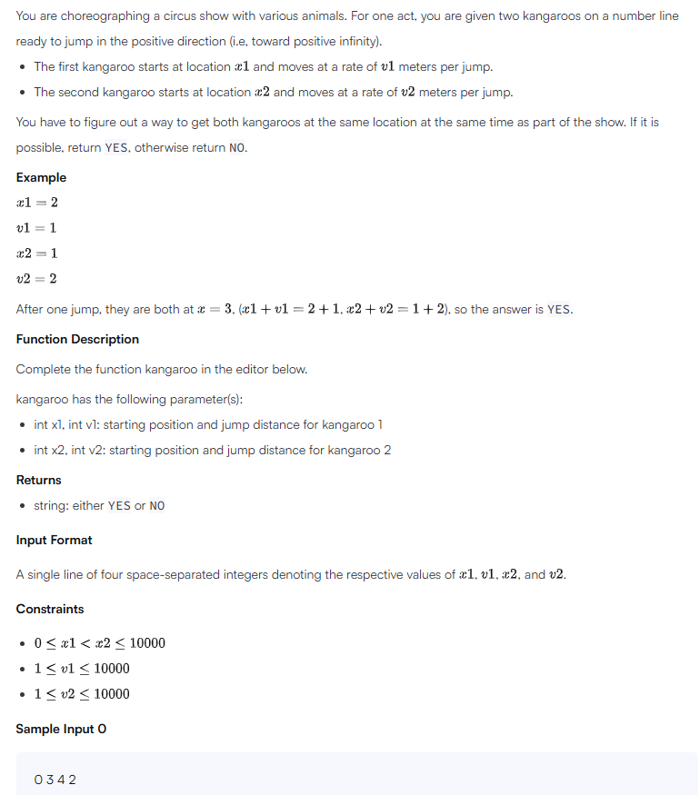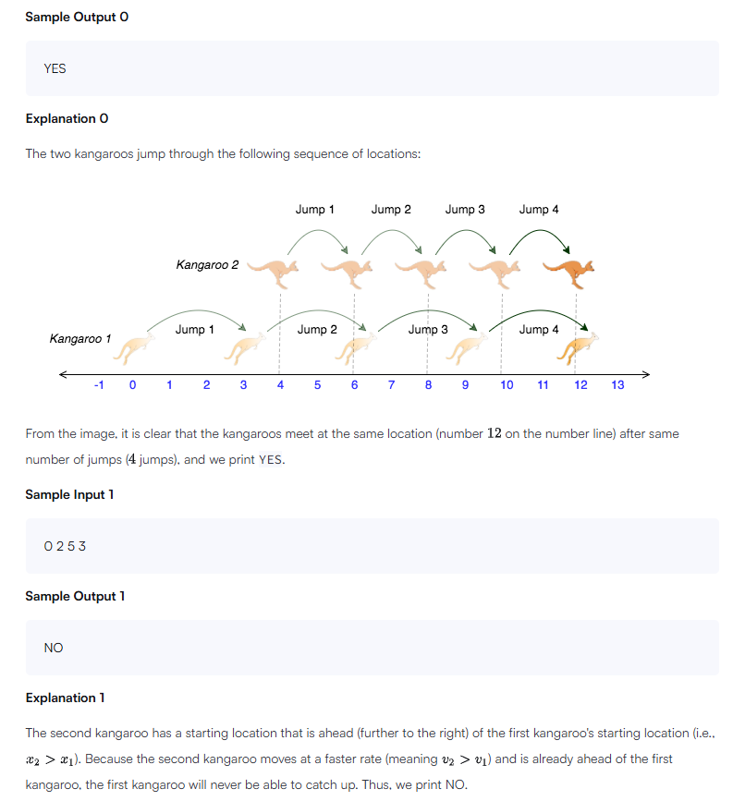

C Code
#include <stdio.h>

int main() {
int x1, v1, x2, v2;
scanf("%d %d %d %d", &x1, &v1, &x2, &v2);

// Kangaroo 1 starts behind (x1 < x2), so it must be faster,
// and the gap must be an exact multiple of the speed difference.
if (v1 > v2 && (x2 - x1) % (v1 - v2) == 0)
printf("YES\n");
else
printf("NO\n");

return 0;
}

Screenshot of Successful Submission



